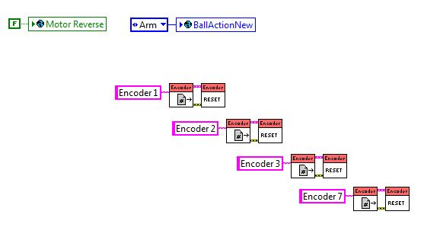

**Set ReverseMotors to false, reinitialized the BallActionNew global variable, and reset (discarded all of the previous data) all of the encoders**.